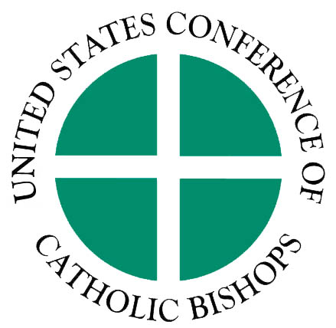
UPDATE ON COMMUNICATION WITH THE
NEW ADMINISTRATION & CONGRESS

Issues for the New Congress and Administration
As the new Administration and Congress begin their work, the USCCB is working hard to communicate the church’s concerns about issues of human life, human dignity, justice and peace. At the bishops’ November 2008 meeting, Cardinal Francis George, President of the USCCB, issued a statement expressing the bishops’ commitment to work with our new leaders to advance the common good of all. On January 13th, Cardinal George sent letters to President-elect Obama and members of the 111th Congress outlining a range of issues of concern to the Catholic community. These include:
- Economic Justice—We support a clear priority for poor families and vulnerable workers in economic recovery measures, including new investments and strengthening the national safety net.
- Health Care—We support comprehensive action to ensure universal health coverage which protects all human life including pre-natal life, provides access for all with a special concern for the poor, respects pluralism, contains costs, and respects the moral and religious convictions of patients and providers.
- International Affairs—We support a responsible transition in Iraq and U.S. investments in foreign aid to overcome poverty, hunger and disease. We also support action on climate change to address the disproportionate impact of climate change and proposed responses on those who are poor.
- Immigration Policy—We will work to fix a broken immigration system and support comprehensive reform that includes a path to earned citizenship.
- Marriage— We support the legal definition of marriage as a union between a man and a woman.
- Education--We support initiatives which provide resources for all parents, especially those of modest means, to choose the education that best addresses the needs of their children.
- Faith-based Groups—We support efforts to strengthen the partnership between government and faith-based groups in ways that do not encourage government to abandon its responsibilities and do not require religious groups to abandon their identity and mission.
- Protecting the Lives of the Most Vulnerable—We will work to defend the right to life from conception to natural death, especially for unborn children and those who are disabled or terminally ill. We will seek common ground on morally sound ways to reduce abortion and will oppose all efforts to expand it or require participation by taxpayers or others.

The USCCB has begun to engage with the transition team and Congressional leaders on many of these issues.

Pro-Life Postcard Campaign
Cardinal George also urged the new Administration and Congress not to divide the nation with aggressively pro-abortion policies, legislation and executive orders. The USCCB Committee on Pro-Life Activities has asked the entire Catholic community to help with a postcard campaign to urge Congress to (1) retain laws against federal funding and promotion of abortion and (2) oppose any bill that includes provisions contained in the “Freedom of Choice Act” (FOCA) or any similar measure.
Timeframe—The goal is to undertake the postcard campaign as soon as possible given tight diocesan schedules and logistical challenges due in part to a larger than anticipated demand for postcards. Most parish activity will take place beginning the last Sunday in January and continuing through the first two Sundays in February. This is the preferred window because existing pro-life provisions in the annual appropriations bills may be subject to attack in Congressional committees by February. However, dioceses may modify the schedule based on local needs. Resources and information on the postcard campaign can be found on the Web sites of the USCCB Secretariat of Pro-Life Activities and the National Committee for a Human Life Amendment.

Ongoing Communication
There will be many opportunities during the coming months to engage the new Administration and Congress on issues of human life, human dignity, justice and peace. We will keep you informed as these opportunities occur. For more information, contact John Carr (jcarr@usccb.org; 202-541-3318) or Joan Rosenhauer (jrosenhauer@usccb.org; 202-541-3381).

